CSE 4471 – Assignment 1

VR AUTO SHOW

Matthew Conte: cs243082
Octobober 6, 2008
Cars of the VR Auto Show
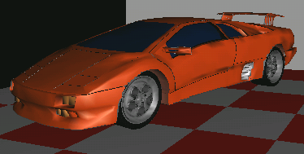
Lamborghini Diablo – 2004

Price: $170,000 USD

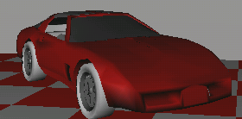
Chevrolette Corvette – 2000

Price: $30,000 USD

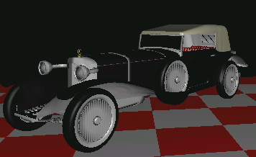
Mercedes 28/95 PS – 1914
Price: $150, 000.00 USD

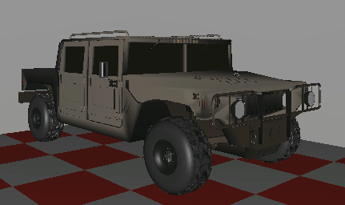

Hummer H2 - 2005
Price: $40,000.00 USD

Description:

This program simulates an interactive virtual reality auto show, where various cars are displayed and can have their rotation animation (if desired) manipulated by the user as he walks around in the scene in a first person view. The user is able to move within the environment and interact with vehicles via a joystick or keyboard.
This application can be ideal for websites for auto shows or car dealerships where potential buyers or enthusiasts can view cars in a way they couldn't as easily in reality.

Software:

This application uses the VE virtual reality library developed at York University. Also used was a virtual environment motion (vem) library to enable character and view motion in first person originally developed by Professor Michael Jenkins which was modified specifically for this application to allow more fluent character movement with a joystick.

Hardware:

The user is able to move and interact in the environment using either a conventional keyboard or a joystick. The program is designed more effectively to use the Logitech attack 3 joystick (Fig 1) due to its conveniently placed 11 buttons.
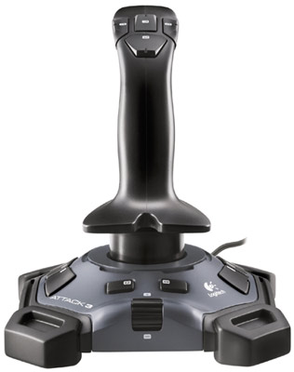
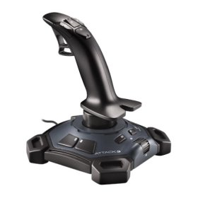

Fig 1a: side view with trigger (button 1) Fig 1b: top handle buttons (left to right, top to bottom) button 4,3,5,2

Fig 1: Logitech Attack 3 Joystick
Character/View Movement:

Action: Keyboard Joystick
-Forward/Backward
movement (Fig 2b&c) - up/down arrow keys - tilt forward/backward

-Pan view left/right
(Fig 2d&e) -left/right arrows keys - tilt left/right

-Tilt view up/down -q/a keys - tilt forward/backward while (Fig 2f&g) holding trigger(button 1)

Note: If user tilts view from original position, any future character movements or release of the joystick trigger will reset view to before tilting like in many first-person shooter games.

Figure 2: Screenshots of character/view movements
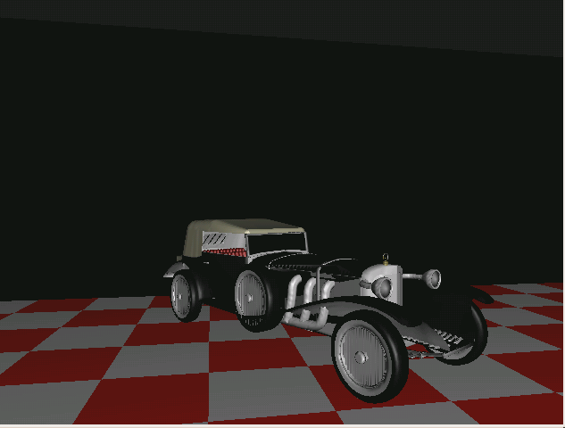

Figure 2a: original position
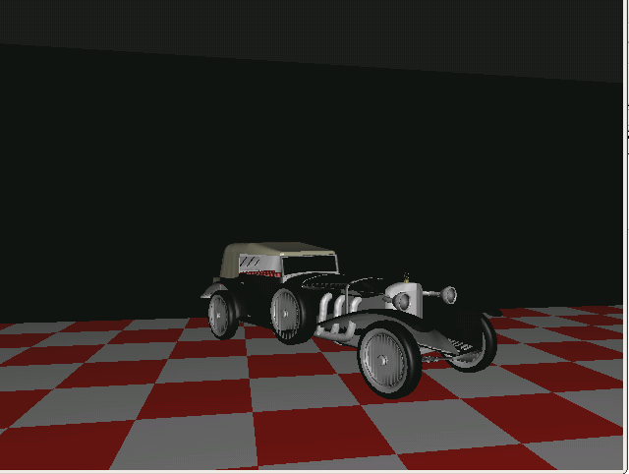
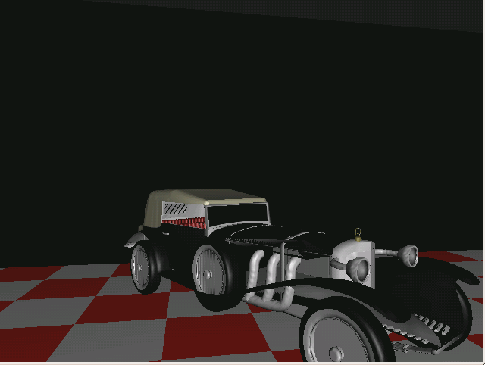

Figure 2b: Move forward Figure 2c: Move backward

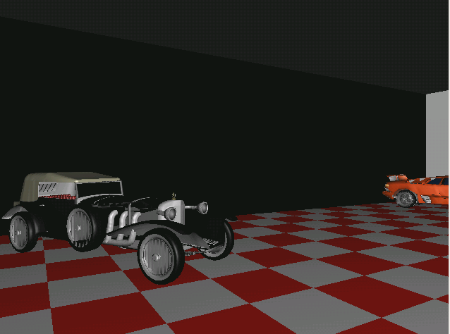
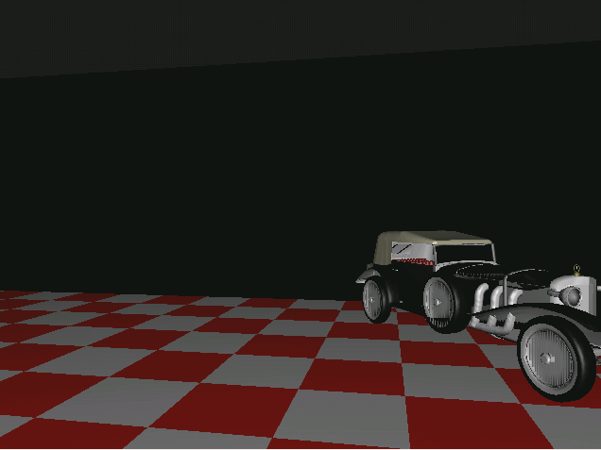

Figure 2d: Pan left Figure 2e: Pan right
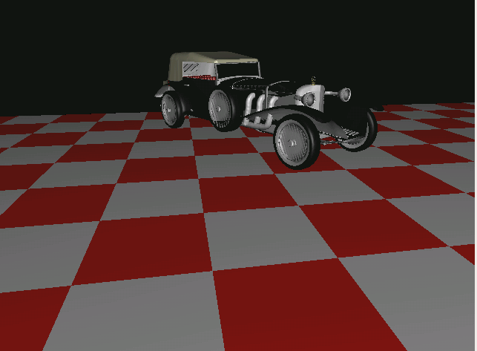
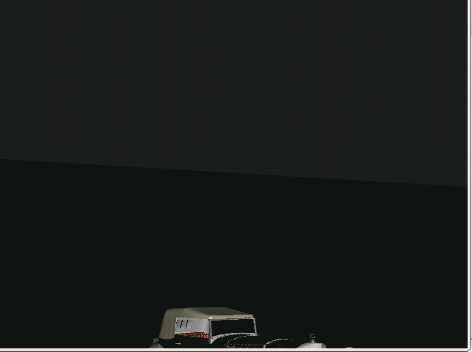

Figure 2f: Tilt down Figure 2g: Tilt up

User/Car Interaction:

Once you're close enough to any car (~ 4 units Euclidean distance), the user is able to manipulate the rotation of the car on every axis.
When you're close enough to a vehicle, a display of the cars axis' of rotation (x,y,z) will be displayed (Figure 3). By default, all cars will initially rotate around the y-axis at a rate of 15 degrees per 1000/60 ms.
The axis that's green indicates the current manipulative axis of rotation (Figure 3). The user can then adjust the direction of rotation or disable roation altogether for the current manupulative axis of rotation and the user can also switch to another axis of rotation.

Action: Joystick Keyboard
- Rotate car counter-clockwise - Button 4 - a key
- Rotate car clockwise - Button 5 - d key
- Disable rotation of car - Button 3 - s key
- Change current manipulative axis - Button 2 - space key
of rotation (order = x,y,z, x,y,z,etc.)

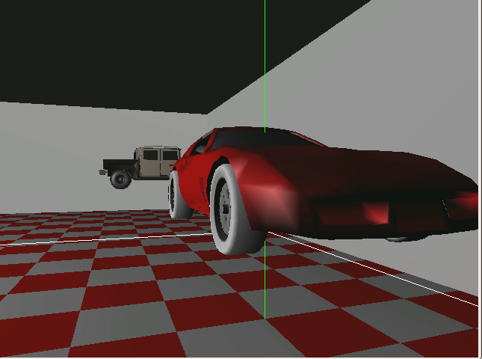
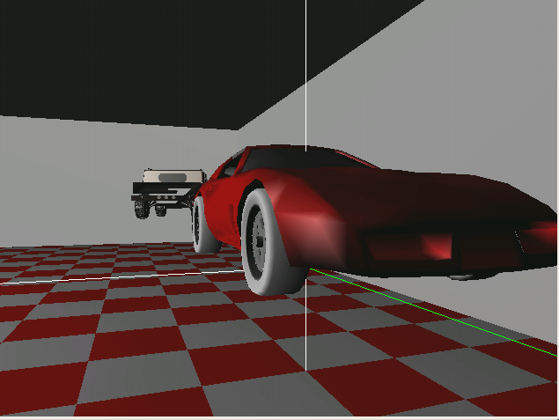
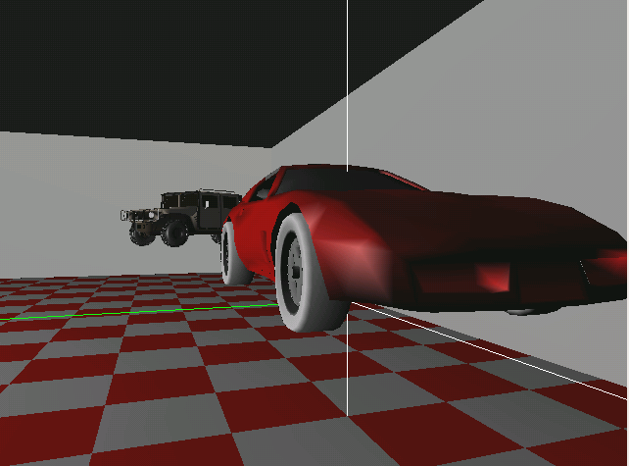

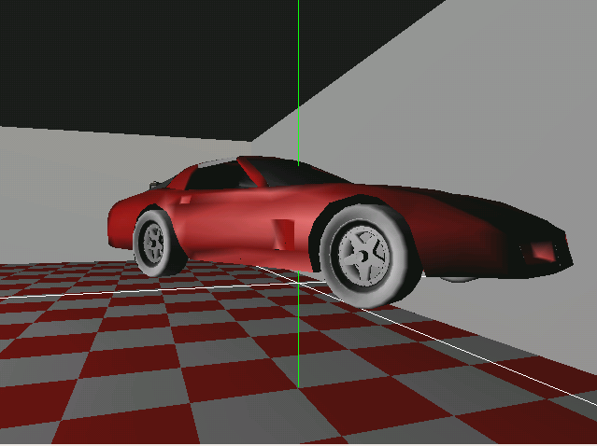
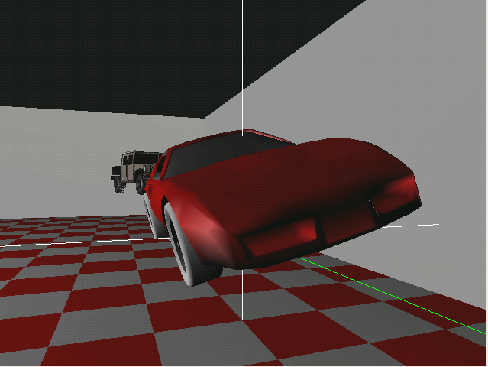
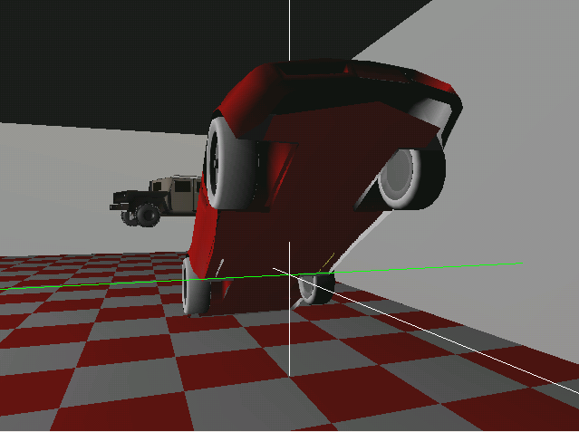

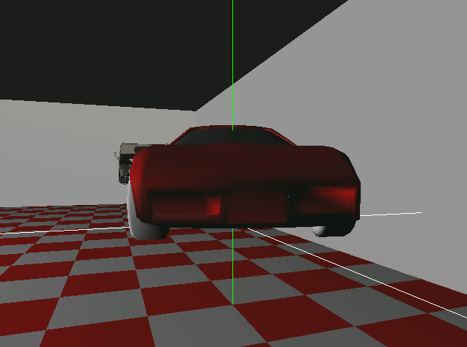
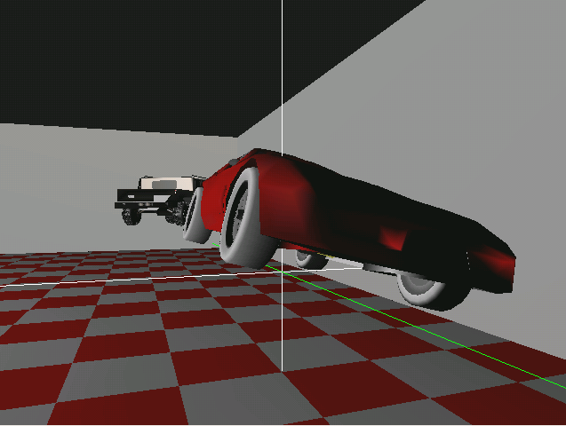
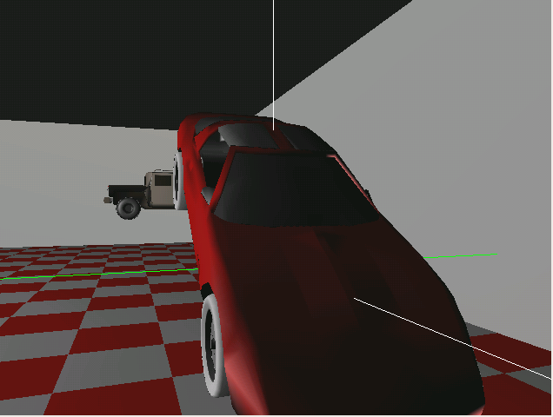
Fig 3a: Rotate about y-axis Fig 3b: Rotate about z-axis Fig 3c: Rotate about x-axis

Figure 3: Car rotating amongst x,y,z axis

Model Sources

- www.turbosquid.com

- www.free3ds.com

